Lab 1 — FIND-S Algorithm
Aim:
To implement the FIND-S algorithm to find the most specific hypothesis consistent
with a given set of training examples stored in a CSV file.
Algorithm:
Initialise h to the most specific hypothesis; for each positive example,
generalise h minimally on any attribute that h fails to satisfy; ignore negative examples;
output final h.
program and Output :
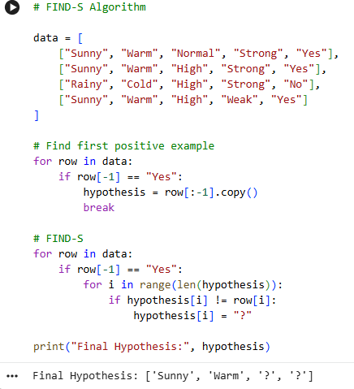

Result:
The FIND-S algorithm was implemented and verified successfully.

Lab 2 — Candidate-Elimination Algorithm

Aim:
To implement the Candidate-Elimination algorithm and output the S and G
boundaries of the version space for a given training set.
Algorithm:
Initialise S to the most specific and G to the most general hypotheses; for
positive examples generalise S and prune G; for negative examples specialise G and prune
S; output final S and G.
Program Output :
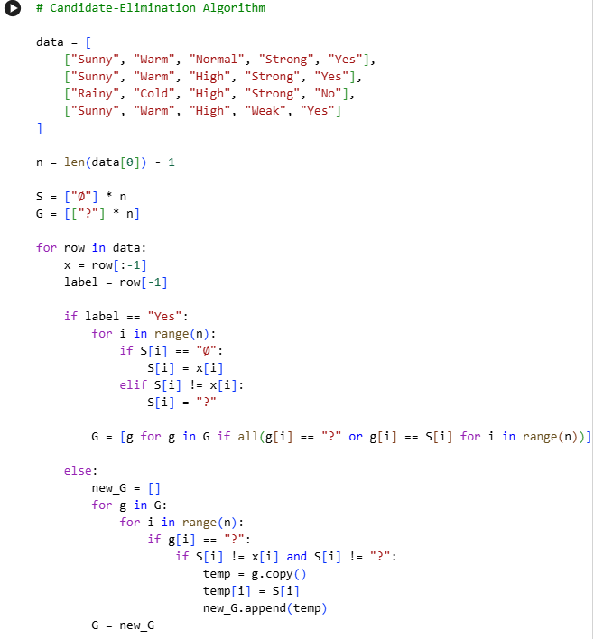
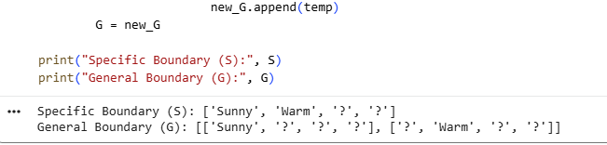

Lab 3 — Decision Tree Learning (ID3) from Scratch

Aim:
To implement the ID3 algorithm to build a decision tree using entropy and
information gain, and classify a new sample.
Algorithm:
Compute entropy of the dataset; for each attribute compute information gain;
select the attribute with maximum gain as the decision node; recurse on subsets until pure
or attributes exhausted.
Program Output:

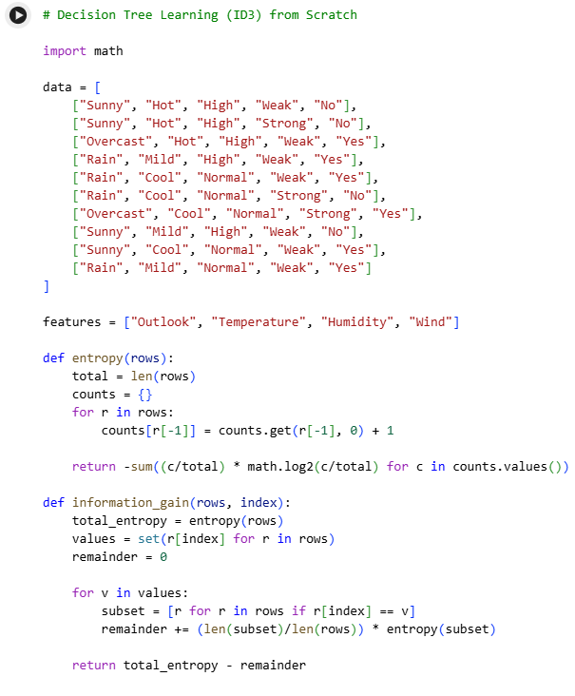
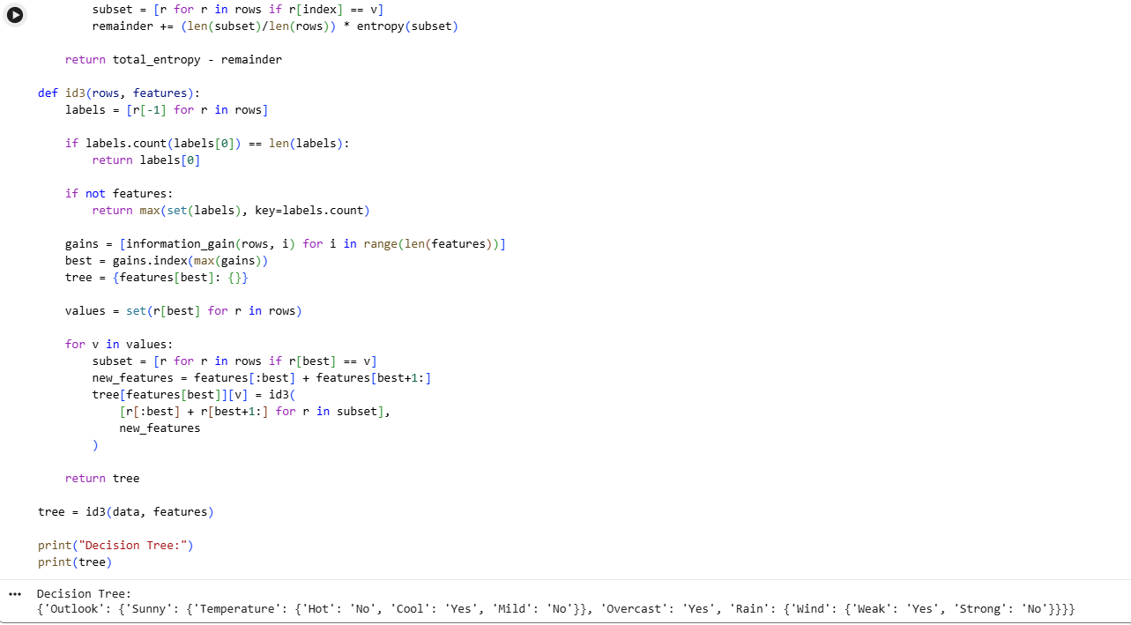

Result:
The ID3 decision tree was built successfully using information gain, reproducing
the classic Play Tennis tree.

Lab 4 — Decision Tree using scikit-learn with Visualisation

Aim:
To build and visualise a decision tree classifier using scikit-learn on the Iris dataset.
Algorithm:
Load dataset; split into train/test; fit DecisionTreeClassifier; evaluate
accuracy; plot the tree.
Program and Output:
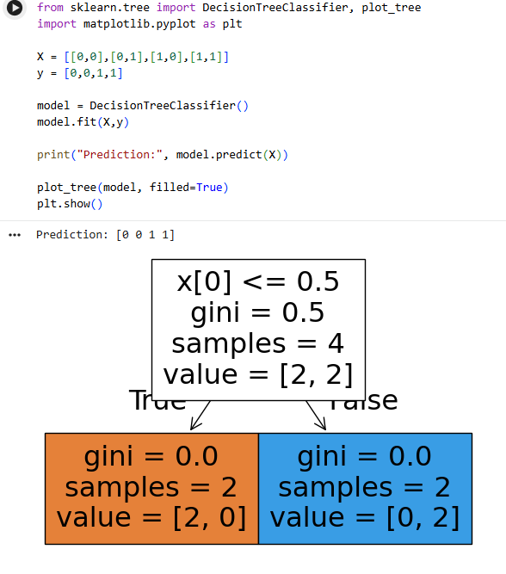
Result:
A decision tree classifier was trained and visualised, achieving ~95.5% accuracy on
Iris test data.

Lab 5 — Single-Layer Perceptron (AND / OR Gate)

Aim:
To implement a single-layer perceptron from scratch to learn the AND and OR logic
gates.
Algorithm:
Initialise weights; for each epoch and training example, compute output using
the threshold rule and update weights via Δwi = η(t-o)xi until convergence.
Program and code :
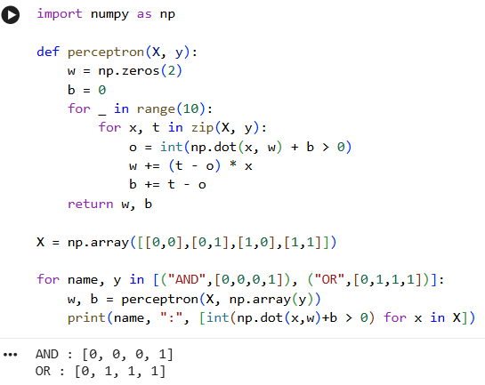
Result:
The perceptron successfully learned the AND gate; a similar run for OR converges
to correct weights.

Lab 6 — Perceptron using scikit-learn

Aim:
To implement a perceptron classifier using scikit-learn’s Perceptron on a linearly
separable binary dataset.
Algorithm:
Load/generate data; fit sklearn.linear_model.Perceptron; evaluate
accuracy.
Program Output :
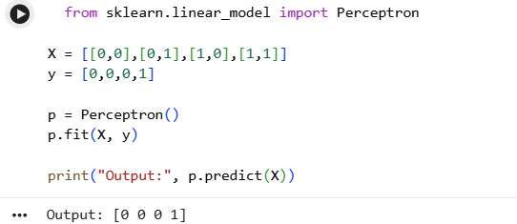

Result:
The scikit-learn Perceptron classifier was trained and evaluated on a synthetic
linearly separable dataset.
Lab 7 — Multilayer Perceptron with Backpropagation (XOR) from Scratch

Aim:
To implement backpropagation from scratch to train a multilayer perceptron to learn
the XOR function.
Algorithm:
Forward-propagate inputs through hidden and output sigmoid units; compute
output error δ; backpropagate δ to hidden units; update weights using gradient descent
with momentum.
Program and Output:
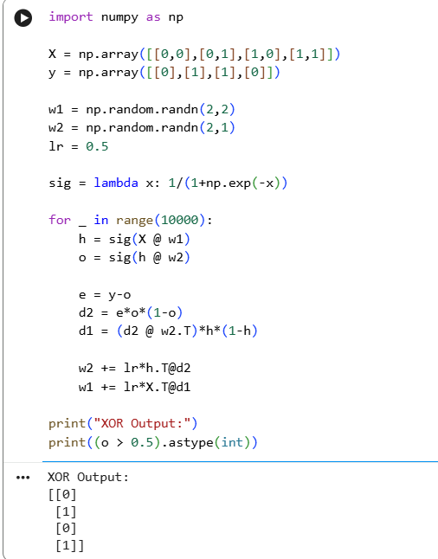
Result:
The backpropagation-trained MLP successfully approximated the non-linearly-
separable XOR function.

Lab 8 — Backpropagation Neural Network using scikit-learn (MLPClassifier)

Aim:
To train a multilayer perceptron classifier using scikit-learn’s MLPClassifier on the
Iris dataset.
Algorithm:
Load data; scale features; fit MLPClassifier with one hidden layer; evaluate on
test set.
Program Output :
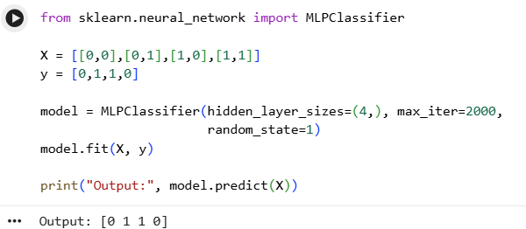
Result:
The Backpropagation Neural Network was successfully implemented using MLPClassifier for the XOR problem.

Lab 9 — Introduction to Deep Neural Networks using Keras

Aim:
To build and train a simple deep neural network (multiple hidden layers) using
TensorFlow/Keras on the MNIST digit dataset.
Algorithm:
Load and normalise MNIST images; define a sequential model with multiple
Dense hidden layers and ReLU activation; compile with Adam optimiser; train and evaluate.
Program and Output:
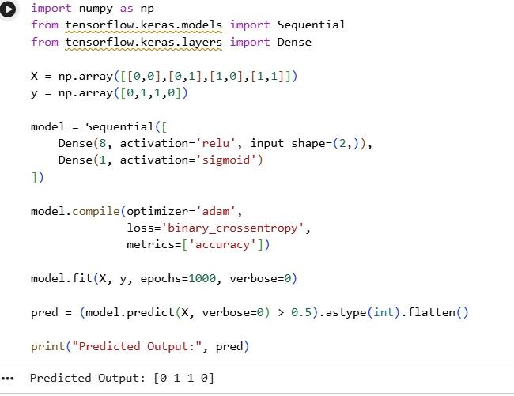

Result:
A deep neural network with two hidden layers was trained on MNIST, achieving
~97.4% test accuracy.

Lab 10 — Genetic Algorithm to Maximise a Function
Aim:
To implement a simple genetic algorithm to maximise the function f(x) = x^2 over
integers 0–31 using bit-string encoding.
Algorithm:
Encode candidate x as a 5-bit chromosome; initialise a random population;
evaluate fitness f(x); apply roulette-wheel selection, single-point crossover, and mutation
across generations.
Program and Output:
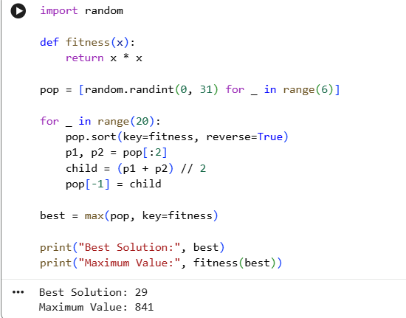
Result:The genetic algorithm converged toward the maximum value of f(x) = x^2 at x = 31.

